**LAB 2**

**CALCULATION OF INTERNAL RESISTANCE**

**CSUS DEPARTMENT OF ENGINEERING**

**EEE 117 LAB**

Author: Ramyasri Singamsetty

Professor: Sergio Aguilar Rudametkin

Date: December 12, 2018

**2.1: INTRODUCTION**

In this lab we built different circuits that modeled the internal resistances of an ammeter, oscilloscope, and a voltmeter. Internal resistance is also referred to as the impedance of a given source, so we observed the different internal resistances given the different sources previously listed. The purpose of this laboratory exercise is to predict and calculate these internal resistances.

**2.2: PROCEDURE**

**Process 1:**

We built two circuits that consisted of a similar schematic setup and components. Both circuits were built using one/two resistors and a voltmeter or ammeter, and a voltage input. A 1-volt voltage input was connected to the resistor/resistors we placed in the circuit. The circuits we built were easy to work with in terms of calculation because KVL and KCL could be easily used to compute necessary current and voltage values.

**Process 2:**

For this portion of the lab, we built the next circuit in order to measure the voltage as accurately as possible. This circuit consisted of a voltage source that was connected to two resistors that were placed in series. The two other connections included a 1-volt input which was sent into the circuit as a voltage source and an ammeter connection (DMM) which was connected to one of the resistors in parallel. We observed that the voltage measurements taken from the voltage source and the voltmeter had very small values. This shows that there is internal resistance in the measurements we took and observed. Next, we solved for the internal resistance of the voltmeter and x1 and x10 probes of the oscilloscope. To do so, we utilized the node voltage method which contains a general resistance. The general resistance gets replaced by the Vout (voltage output) of the voltmeter. From this formula, we isolated the internal resistance to find its value.

**Process 3:**

For this portion of the lab, we built the same circuits and found the internal resistance required relative to the ammeter instead of the voltmeter. The two circuits required are shown in Figure 1. 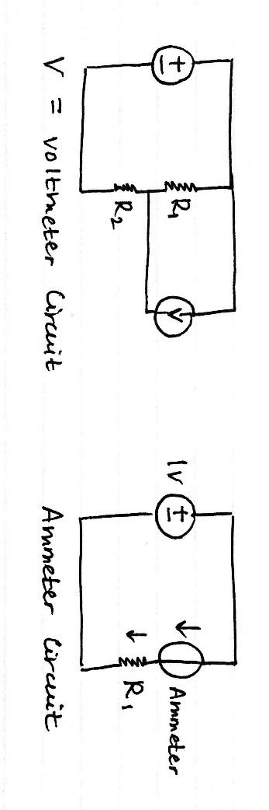

*Figure 1(a &b): General Circuits Required for Lab*

**ANALYSIS**

**Process 1: Computation of Voltage Output and Current**

Using the voltmeter circuit shown in the image above, we solved for the voltage drop. We used the resistance values R1 = 764 Ohms and R2 = 759 KOhms. These values are large because we were advised that large resistances make the value of internal resistance more significant since they will be less than the voltage value. We then applied voltage division to R1 and with this computation we determined the predicted values the voltmeter would show (Figure 1). 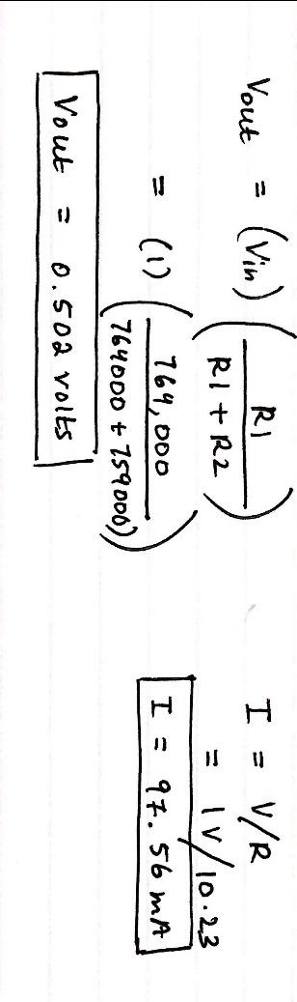

To find the current, we utilized a smaller resistance value, R = 10.23 Ohms. The following shows the result of the current value by using Ohm’s law. 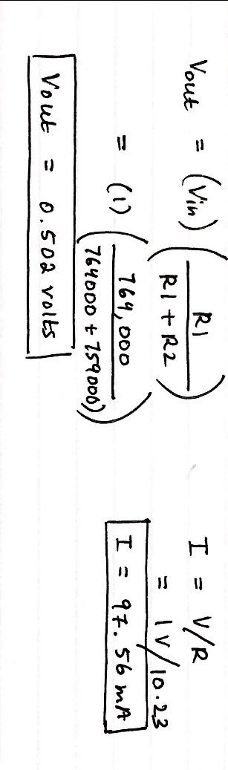

**Process 2: Computation of Internal Resistance of the Voltmeter**

**A.Voltage:** For this portion of the lab we measured the voltage value of the voltmeter and comparing this value to the expected voltage value. We observed that there is a significant difference between the expected voltage which was 0.502 V and the measured value.

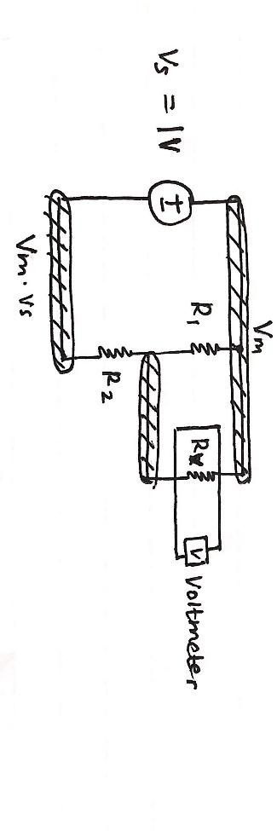

We used the node voltage method to find the internal resistance by using the voltage input and the voltage from the voltmeter. To do this, we used general circuit analysis and picked a ground node to help find the internal resistance. Figure 2 shows how the nodes and ground node is setup relative to the resistances.

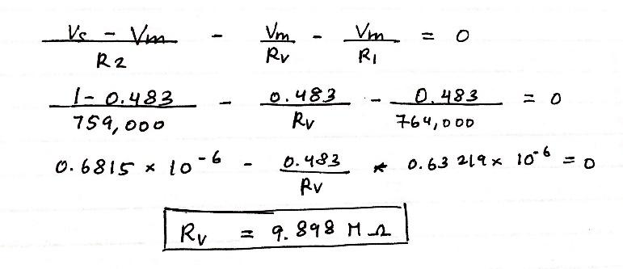

*Figure 2: Value of Internal Resistance Relative to Voltmeter*

**B. Computation of Internal Resistance of Probe 1:**

To calculate the internal resistance of the x1 probe, we used the resistor (R2) that is in parallel to the x1 probe. It would be harder to calculate the internal resistance of the other resistor, R1 because it is not directly connected to the x1 probe. We constructed our circuit in a way in which it would be easy to find the internal resistance value by using circuit analysis.

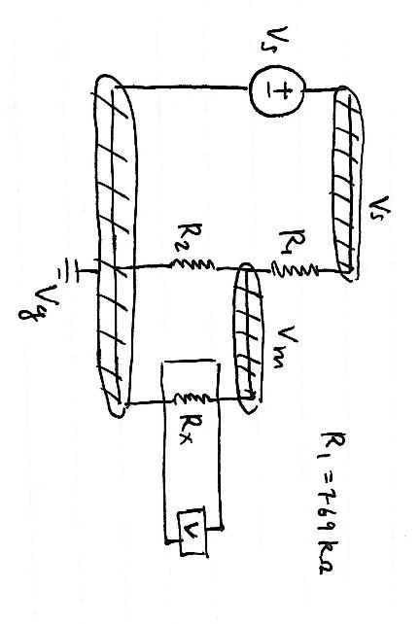

*Figure 3: Circuit to Calculate Probe Internal Resistance Values*

We plugged in the variables we used in the circuit in the equation seen below, which we derived using node voltage method. 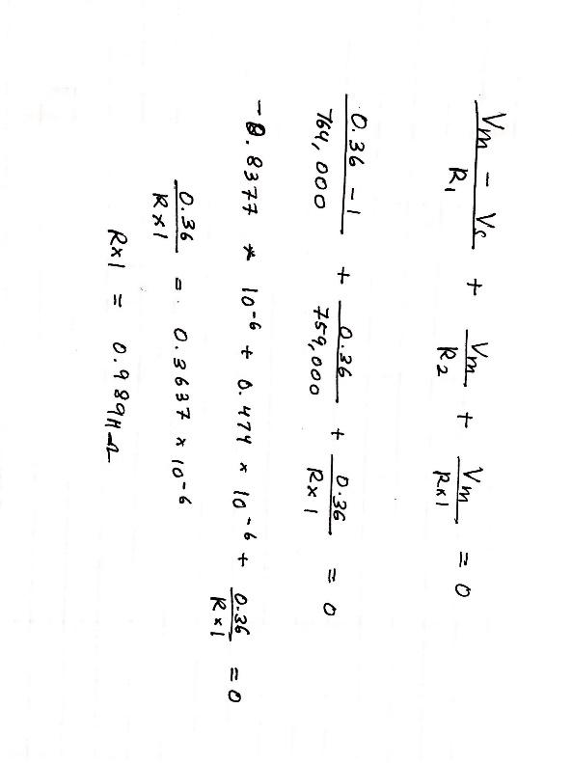

**C. Computation of Internal Resistance of X10 Probe**

For this portion of the lab we used the same procedure as we used to compute the internal resistance of X1 probe. We derived the following equation using the node voltage method and referred to the circuit in Figure 3.

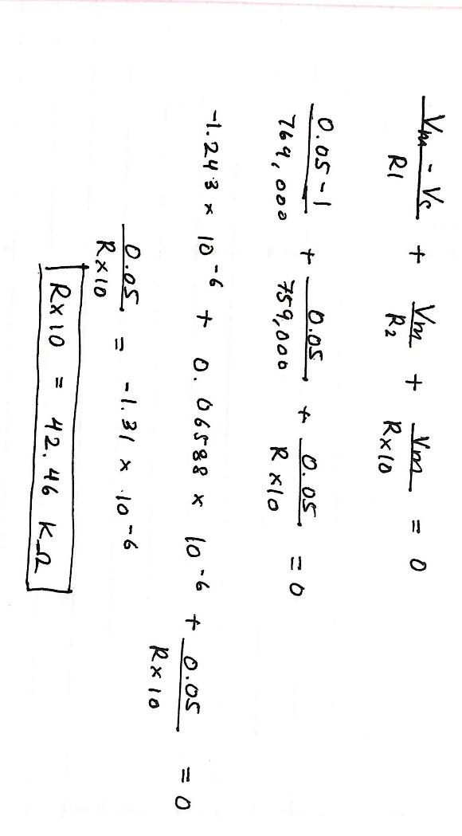

We found the internal resistance of the probe X10 to be 42.46 KOhms.

**Process 3: Internal Resistance of the Ammeter**

For this part of the lab we found the internal resistance of the ammeter. We observed that the ammeter circuit was causing the current in the circuit to drop significantly when compared to the value of the actual current. We connected the ammeter to the internal resistor in series and then used KVL to find the value of the internal resistance. Figure 4 below shows the circuit and the calculated internal resistance value. 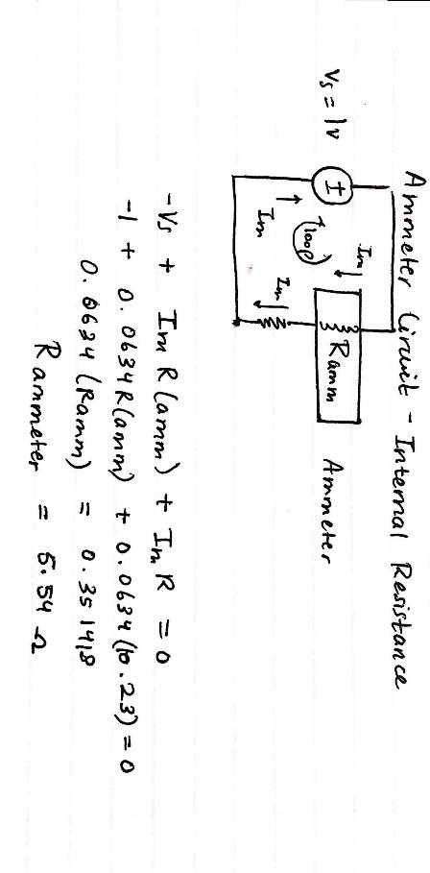

**DATA**

**PROCESS 1 DATA:**  
The following shows expected data and calculated data taken from process 1.

Voltmeter Circuit Data:

|  |  |  |
| --- | --- | --- |
|  | Expected | Measured |
| Voltage | 1 | 1 |
| Resistor 1 | 750000 Ohms | 764000 Ohms |
| Resistor 2 | 750000 Ohms | 759000 Ohms |
| Vm | 0.502 V | 0.483 V |

**PROCESS 2 DATA:**

The following shows expected data and calculated data taken from the internal resistances circuits built using the voltmeter and the probes on the oscilloscope.

|  |  |  |
| --- | --- | --- |
|  | Vm Used | Internal Resistance |
| Voltmeter | 0.483 V | 9.865 M Ohms |
| X1 | 0.36 V | 0.9898 MOhms |
| X10 | 0.05 V | 42.46 KOhms |

**PROCESS 3 DATA:**

Internal Resistance values obtained from circuit node voltage calculations.

|  |  |  |
| --- | --- | --- |
|  | Current | Internal Resistance |
| Expected | 97.56 mA | N/A |
| Measured | 63.4 mA | 5.54 Ohms |

**CONCLUSION**

This lab was very important due to the fact that we were given the opportunity to build simple circuits using different components. It was also a test to see how well we knew how to apply circuit analysis to the circuits we built. We mainly applied the use of KCL and KVL to the circuits we built to find the internal resistances depending upon the different components we used. The main purpose of this lab was to gain practice in computing the internal resistance value which we were able to achieve.